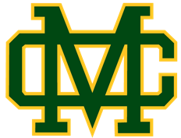

**MIRA COSTA -- CHEERLEADING**

**SUMMER CHEER CAMP  
July 24-27, 2017 -- 9:00AM - 2:00PM  
$275 (new campers)**

**$250 (returning campers)**

**Children K-8th grade are invited to a high energy cheerleading and skills camp! You will learn sidelines, cheers, dances and cheerleading fundamentals from the Nationally Ranked, COSTA CHEERLEADERS!**

**There will also be games and arts & crafts.**

***We will have a final performance for family and friends on Thursday, July 27th @ 1:30pm***

**Clinic Time:** 9:00AM – 2:00PM

**Where:** Mira Costa High School

1401 Artesia Blvd, Manhattan Beach, CA 90266

(Drop off on Peck Ave. near Life Science Building)

**Provided:** Water, snack

**What to bring:** Water bottle, sack lunch, sunscreen, comfortable shoes, light jacket, hair in ponytail

**Medical Release form will be required at check-in**

Register and Pay at: **www.costacheer.com**